Vojík M., Sádlo J., Petřík P., Pyšek P., Man M. & Pergl J. (2020) Two faces of parks: sources of invasion and habitat for threatened native plants. – Preslia 92: 353–373.

Electronic Appendix 4. – Analysis of PCA scores for climatic variables.

1. Summary of PCA for define the relevant axes for choose appropriate axes for replace original climatic variables.
Total variation is 1691.000

Summary Table:
Statistic Axis 1 Axis 2 Axis 3 Axis 4
Eigenvalues 0.4680 0.1993 0.1413 0.0709
Explained variation (cumulative) 46.80 66.74 80.87 87.96

2. The climatic data collinearity: „Resp. 1, 2, 3“ contains the scores characterising the extent and direction of each climatic variables; c1, c2, c3 are fit values for the variables (in bold are the best fitting).
 | Resp.1 | Resp.2 | Resp.3 | c1 | c2 | c3
01 – Annual Mean Temperature [°C*10] | -0.8275 | 0.5013 | 0.2159 | 0.6847 | 0.2513 | 0.0466
02 – Mean Diurnal Range [°C] | -0.6258 | -0.1685 | 0.2536 | 0.3916 | 0.0284 | 0.0643
03 – Isothermality | -0.0157 | -0.7793 | 0.4010 | 0.0002 | 0.6073 | 0.1608
04 – Temperature Seasonality [standard deviation] | -0.0636 | -0.1979 | 0.1110 | 0.0040 | 0.0392 | 0.0123
05 – Max Temperature of Warmest Month [°C*10] | -0.7967 | 0.5749 | 0.1513 | 0.6347 | 0.3305 | 0.0229
06 – Min Temperature of Coldest Month [°C*10] | -0.7983 | 0.2509 | 0.4046 | 0.6372 | 0.063 | 0.1637
07 – Temperature Annual Range [°C*10] | -0.3920 | 0.6893 | -0.2405 | 0.1536 | 0.4752 | 0.0578
08 – Mean Temperature of Wettest Quarter [°C*10] | -0.6072 | 0.5452 | 0.1751 | 0.3687 | 0.2972 | 0.0307
09 – Mean Temperature of Driest Quarter [°C*10] | 0.2269 | 0.0477 | 0.7272 | 0.0515 | 0.0022 | 0.5288
10 – Mean Temperature of Warmest Quarter [°C*10] | -0.8000 | 0.5731 | 0.1476 | 0.6400 | 0.3284 | 0.0218
11 – Mean Temperature of Coldest Quarter [°C*10] | -0.8098 | 0.2114 | 0.4065 | 0.6557 | 0.0447 | 0.1652
12 – Annual Precipitation [mm/year] | 0.8659 | 0.4539 | 0.1088 | 0.7498 | 0.206 | 0.0119
13 – Precipitation of Wettest Month [mm/month] | 0.6739 | 0.6169 | -0.2635 | 0.4541 | 0.3805 | 0.0694
14 – Precipitation of Driest Month [mm/month] | 0.8466 | 0.2747 | 0.4269 | 0.7167 | 0.0755 | 0.1823
15 – Precipitation Seasonality [coefficient of variation] | -0.4914 | 0.0536 | -0.7741 | 0.2415 | 0.0029 | 0.5993
16 – Precipitation of Wettest Quarter [mm/quarter] | 0.7024 | 0.5962 | -0.2667 | 0.4933 | 0.3554 | 0.0712
17 – Precipitation of Driest Quarter [mm/quarter] | 0.8466 | 0.2651 | 0.4332 | 0.7167 | 0.0703 | 0.1876
18 – Precipitation of Warmest Quarter [mm/quarter]. | 0.7832 | 0.4460 | -0.2149 | 0.6134 | 0.1989 | 0.0462
19 – Precipitation of Coldest Quarter [mm/quarter]. | 0.8279 | 0.2031 | 0.4973 | 0.6855 | 0.0412 | 0.2473

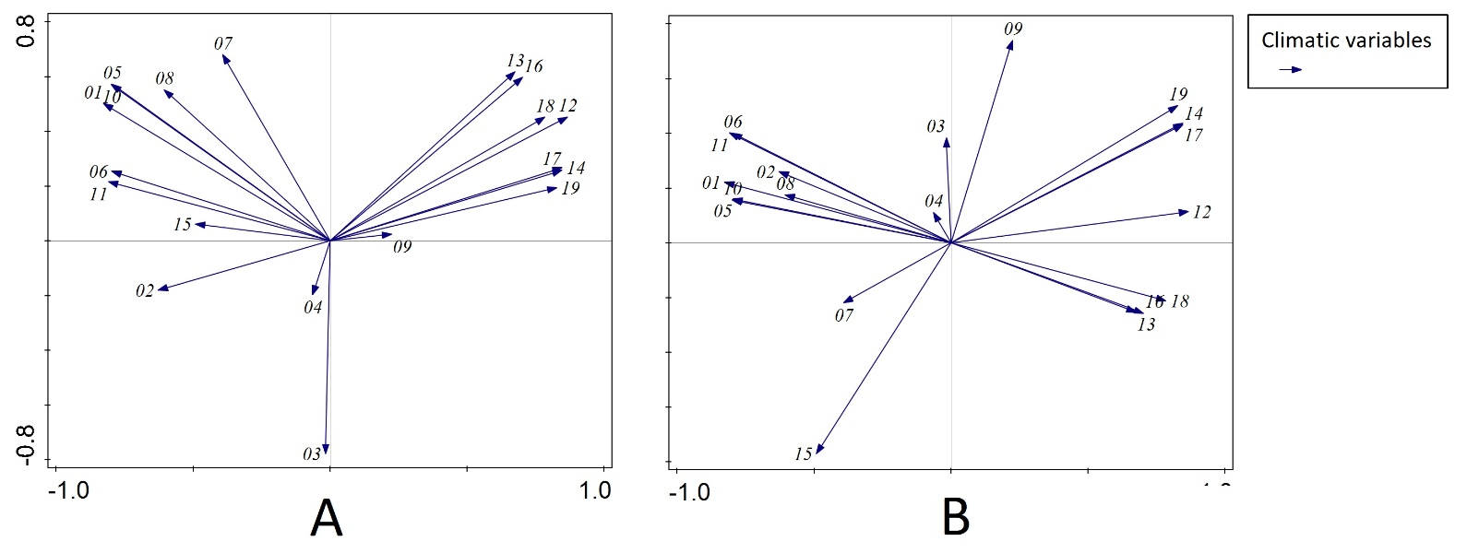

3. The graph of PCA – horizontal is axis 1, vertical is axis 2 (A) and axis 3 (B).

Electronic Appendix 6. – The role of parks in the invasion process – model parameters

Maximal model (MM) parameters:

Deviance Residuals:
Min 1Q Median 3Q Max
-2.67571 -0.74569 -0.02779 0.82794 2.62502

Coefficients:
Estimate Std. Error z value Pr(>|z|)
(Intercept) 0.3988850 0.2527742 1.578 0.114559
park_size -0.0015120 0.0017069 -0.886 0.375710
altitude 0.0006660 0.0005149 1.294 0.195830
no_woody_taxa 0.0010972 0.0009820 1.117 0.263831
casual -0.1349329 0.0399956 -3.374 0.000742 ***
naturalized -0.1007889 0.0329041 -3.063 0.002191 **
invasive -0.2345281 0.0513956 -4.563 5.04e-06 ***
neophytes 0.1773620 0.0418257 4.241 2.23e-05 ***
---
Signif. codes: 0 ‘***’ 0.001 ‘**’ 0.01 ‘*’ 0.05 ‘.’ 0.1 ‘ ’ 1

(Dispersion parameter for binomial family taken to be 1)

Null deviance: 132.07 on 85 degrees of freedom
Residual deviance: 98.16 on 78 degrees of freedom
AIC: 371.68

Number of Fisher Scoring iterations: 4

Minimal adequate model (MAM) parameters:
Deviance Residuals:
Min 1Q Median 3Q Max
-2.89027 -0.76762 -0.01292 0.91767 2.55346

Coefficients:
Estimate Std. Error z value Pr(>|z|)
(Intercept) 0.71908 0.15097 4.763 1.91e-06 ***
casual -0.14214 0.03441 -4.131 3.62e-05 ***
naturalized -0.10712 0.03194 -3.354 0.000797 ***
invasive -0.26002 0.04764 -5.458 4.82e-08 ***
neophytes 0.19083 0.03995 4.777 1.78e-06 ***
---
Signif. codes: 0 ‘***’ 0.001 ‘**’ 0.01 ‘*’ 0.05 ‘.’ 0.1 ‘ ’ 1

(Dispersion parameter for binomial family taken to be 1)

Null deviance: 132.07 on 85 degrees of freedom
Residual deviance: 101.26 on 81 degrees of freedom
AIC: 368.78

Number of Fisher Scoring iterations: 4

Comparing both models using Akaike’s Information Criteria (AIC):
> AIC(MM,MAM)

df AIC
MM 8 371.6760
MAM 5 368.7811

